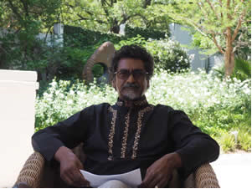

Jay Naidoo
Jay Naidoo was General Secretary of the Congress of South African Trade Unions. He then served as Minister responsible for the Reconstruction and Development Programme in President Mandela's office and as Minister of Post, Telecommunications, and Broadcasting.
He is the former Chair of the Board of Directors of the Global Alliance for Improved Nutrition headquartered in Geneva. Jay sits on the Board of the Mo Ibrahim Foundation established to promote African development through a focus on promoting good governance.
He serves in an advisory capacity for a number of international organizations including the UN Broadband Commission and the UNSG`s Lead Committee on Nutrition. He is the Patron of ‘Scatterlings of Africa’ a paleontological foundation linking archaeological sites across Africa.
He has gained many honors, including becoming the Chevalier de la Légion d’Honneur, one of France’s highest decorations, received the ‘Drivers for Change Award’ from the Mail & Guardian, The Ellen Kuzwayo Award from the University of Johannesburg, an Honorary Doctorate Technology Degree in Engineering and the Built Environment from the Durban University of Technology.
In 2014 Jay was awarded a lifetime achievement award prize in recognition for “Democratic Governance and Development in Africa” by the Millennium Excellence Foundation based in Ghana.

