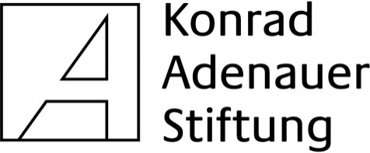

Job announcement

Job Title: Team Leader
Job Type: Full Time – 40 months
Location: Chisinau, Republic of Moldova

Starting from 01 September 2018 Konrad-Adenauer Stiftung e.V. (KAS) will coordinate the implementation of the EU-funded project “Grassroots Civil Society Development Facility in the Republic of Moldova” (Grant Contract 2018/397-5109). The main aim of the project is to contribute to the development of civic engagement and of grass roots civil society in Moldova that actively promotes and monitors transparency and accountability of public institutions, including in the implementation of the EU-Moldova Association Agreement. KAS is implementing the project together with four local partner organisations and in close cooperation with the EU-Delegation in Moldova.

We are looking for a Team Leader responsible for the overall direction and coordination of the project, working in an EU project office in Chisinau.

Duties

- Setting up and running the EU project office in Chisinau;
- Leading, coordinating and supervising the work of the project team;
- Guiding the overall implementation and management of the project;
- Project planning and overseeing the day to day activities of the project in accordance with the EU contract;
- Ensuring an adequate communication between the project team, project partners and the backstopping offices in Berlin and Brussels;
- Drafting a visibility concept and ensuring the external visibility of project activities in accordance with the EU visibility guidelines;
- Monthly and yearly narrative reporting as well as controlling the monthly and yearly financial reporting;
- Regular progress reporting to the EU Delegation in Chisinau;
- Designing a monitoring plan for the project activities and overseeing the implementation of the plan;
- Coordinating the work of the project’s Steering Committee;
- Briefing of short term experts at the start of their mission and debriefing them at the end;
- Holding regular meetings with the project team and the partners to discuss the work progress and administrative issues;
- Ensuring the quality of work produced on the basis of ToR by different experts and project staff;
- Supervising incoming and outgoing project mail and communications;
- Timely completion and submission of all reports, as stipulated in the project application and the EU general conditions.

Qualifications

- University degree in politics, social sciences, journalism or law;
- Experience in implementing EU-funded projects;
- At least 5 years of working experience in the Civil Society sector or related and relevant areas of responsibilities;
- Experience in leading complex projects in field of development cooperation/democracy promotion and/or leadership responsibility and management experience in private, non-governmental or public sector organizations;
- Excellent communication skills;
- Experience in personal management;
- Excellent written command in English, Romanian and Russian;

Applications

Applications containing a Résumé/CV and a motivation letter are to be sent in English and in electronic version to info.chisinau@kas.de

Deadline for submission of applications: 07.09.2018

