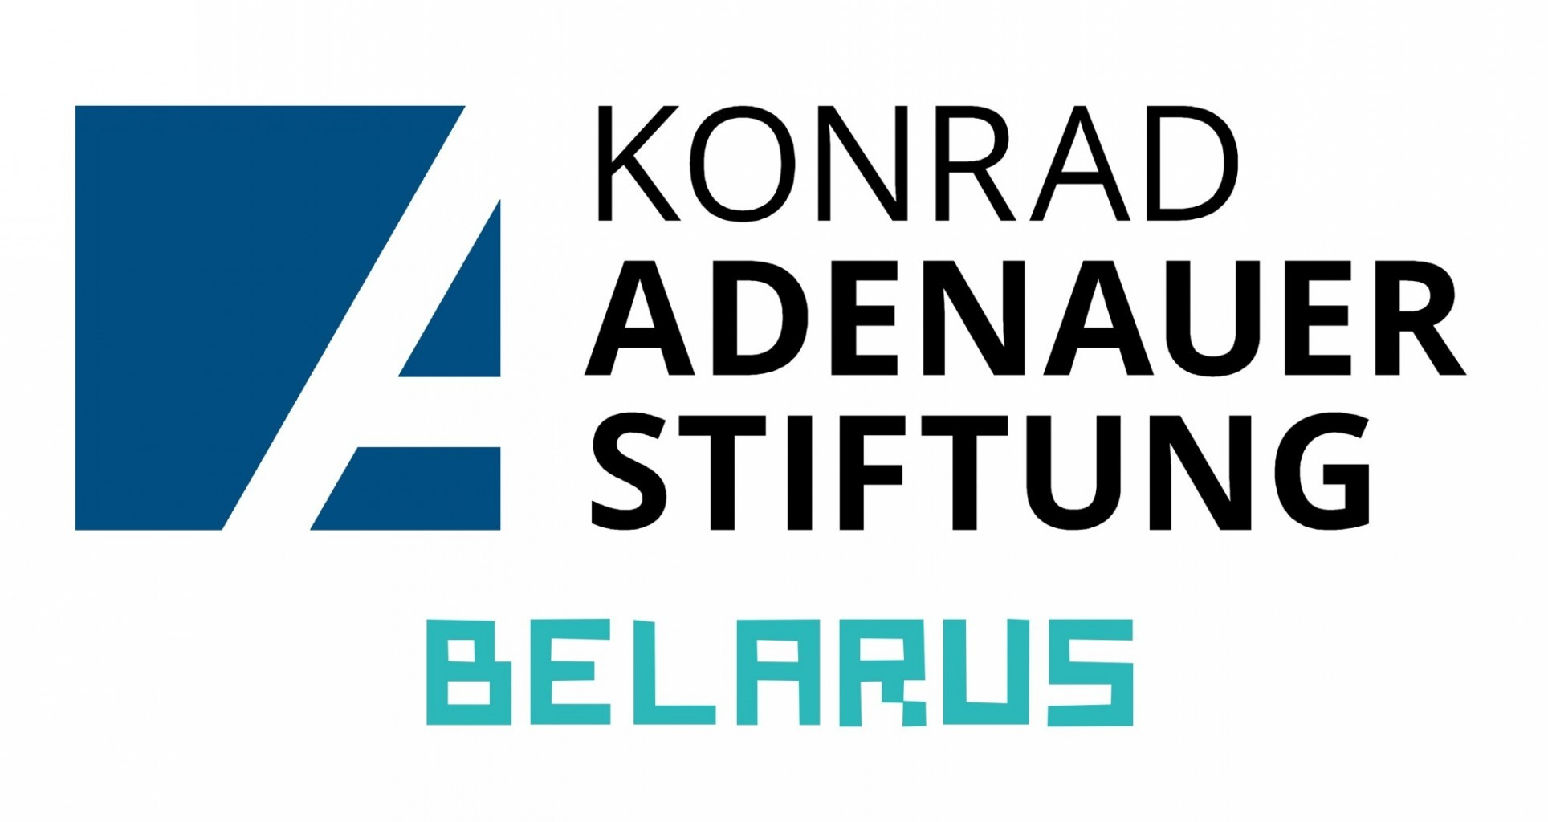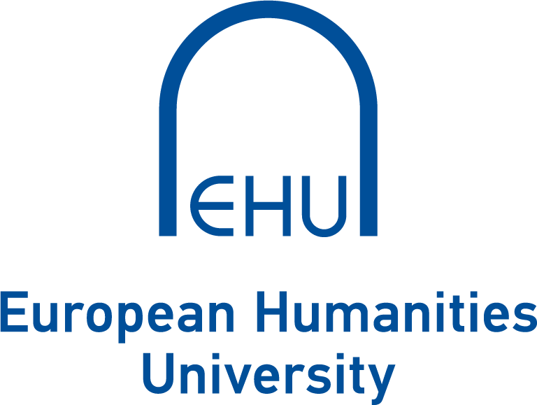

Essay contest

“Taking the living memory of World War II to the next generation”

Commemorating the 75th-anniversary the end of World War II in Europe, the European Humanities University (EHU) and Konrad-Adenauer-Stiftung Belarus Country Office (KAS-Belarus) announce an essay contest for Belarusian youth “Taking the living memory of World War II to the next generation”.
Young people are invited to write an essay on one of the following topics centering around perspectives that are beyond the official state narrative:
- What would you change in the way we the state and society remember WWII to awake interest its legacy to today’s and future generations?
- Imagine Minsk invites European leaders for the 100th anniversary of the end of WWII – What should the commemoration festivities look like?
- How can we include the last 75 years and all the formative events which have happened in Europe following WWII into after the end of the war into our “culture of remembrance”?
- Your own idea in line with the general topic
NB! Essays (2000-3500 characters) should be written by Belarusian nationals of the age 16-28 in one of the following languages: English, German, Belarusian, or Russian and submitted via info.belarus@kas.de by the deadline of July 1.
During AY 2020/21 Autumn Semester, a public presentation of the winning essays will take place at the EHU Campus in Vilnius Old Town. The best student essays will be published and the winners will be taken on a study trip to Berlin.

