**MULTISTAKEHOLDER DIALOGUE ON DIGITAL COOPERATION**

KAS Kenya office in partnership with the Kenya ICT Action Network (KICTAnet) convened a two days Multistakeholder Dialogue Forum on Digital Cooperation on the 3rd and 4th of October, 2019. The main aim for this forum was to deliberate on the effective ways to take action on the UN Secretary General’s High-Level Panel’s report on Digital Cooperation, to assess the feasibility of contextualizing the recommendations to the Kenyan context with a keen focus on access/inclusion and Internet Governance. The KAS/KICTANet convening had representation from Communications Authority of Kenya (ICT Sector Regulator), civil society, academia and the private sector). Discussions and outcomes were based on the key thematic areas which included; Digital divide and inclusion of marginalized groups, future of work and education, human rights in the digital age, Ethical AI principles and the future of internet and design of the digital space using a multistakeholder approach.

Key outcome on digital inclusion was that no one should be left behind, everyone should have affordable and meaningful connectivity however,50% of the world is still offline and it is even going to take longerto achieve global digitalization. In Kenya, for example, setting up of Huduma centers, new curriculum development, electrification and increment of free internet access among other measures have been put in place to ensure creation of a digital economy. The best thing is that people have shown a positive attitude towards embracing technology for example in the use of M-pesa, making it easy for connectivity to spread.

The main challenge on digital trust was that there is need for defining the real journalist as well as advocating for personal integrity and honesty which then reflects on the masses. With regards to the ethical dimension of digital technologies it was agreed that computers cannot take over everything, human beings have a role to play too. Technology alone will not solve our problems but people will. Digitalization should also DO-NO-HARM but instead people should be curious on the new technologies, the new changes and even new jobs that come up. People must be willing to reskill, upskill and even develop new curriculums to fit in the future of work. On the question of Multistakeholder approach to address diverse issues, it was agreed that it is vital since it keeps the spirit of digital cooperation and more pressure is given to the decision makers to ensure digital policies and governance is constantly in check.

Diverse models on Multistakeholderism in Internet Governance Forums were also discussed in groups to see whether the proposed models i.e. Internet Governance forum ‘’Plus’’, Distributed Architecture model and Digital Commons Architecture were feasible. Conclusively it was agreed that the models still need to strengthened, have them more inclusive in terms of participation, put in more resources for efficiency and lastly bodies like the UN should be more supportive and extended to the regional levels.

The internet plays a key role in the democratic space and thus internet governance should constantly be relooked at to ensure its consistence and positive contribution. At the end of the day, the diverse stakeholders represented urged that people need to be more vocal in terms of who is representing them, since everything rises and falls on leadership.

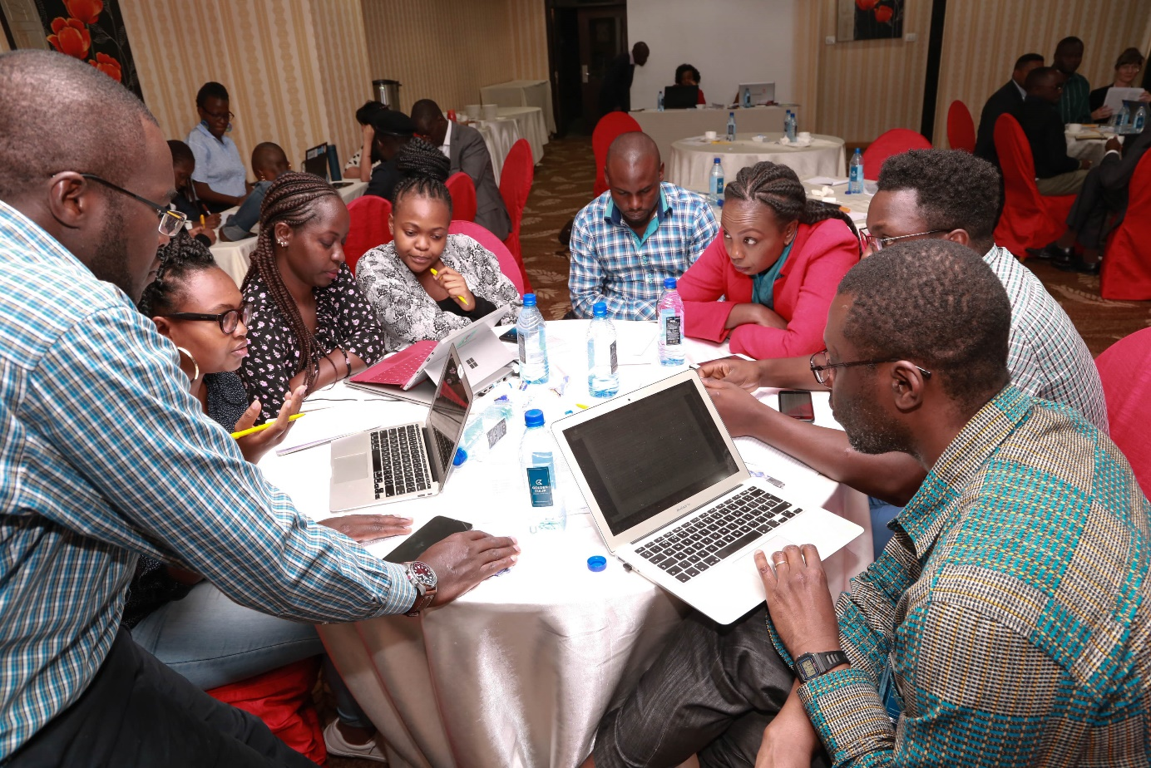*Group discussion on Multistakeholderism in Internet Governance Forums*

*Wambui moderating a panel discussion on Digital Governance*